Amarillo Medical Specialists, LLP
1215 S. Coulter Street
Amarillo, Texas 79106

Welcome to TeleHealth !
USING THE HEALOW APP on your iPhone or Android
for remote Tele Health visits

BEFORE YOU START

- Verify that you can use your Healow app to connect to our patient portal. Can you see your labs, and your appointments ?

- Check to see if the TeleVisit appointment is on your list. It will say ‘Televisit’ toward the right. If you tap Televisit, you can choose to set a reminder 1 hour ahead so your phone will remind you close to when its time for your appointment.

- Telehealth visits contain the same content as a regular visit, and we put them on our schedule just like a regular visit in person. Please log in on time so that we can see you.

- Healow Telehealth uses your phone, screen, network connection, microphone and camera ALL AT THE SAME TIME. It uses up a lot of battery life sometimes, so please have your phone charged up, or plug your phone into a power source!

- If you have diabetes, our office would like for you to share your blood glucose meter, insulin pump or artificial pancreas information. If you subscribe to Glooko, Medtronic CareLink, or Roche AccuChek connect, please upload at least 30 minutes before your visit. That way it will be available for us to view.

- The program will ask you for your vital signs today. Please weigh yourself. If you have a BP cuff , write down your blood pressure, pulse, height and weight so you can enter them into the visit screen. If you have a fever, please take your temperature.

STARTING THE VISIT

- You can log in up to 15 minutes before your scheduled appointment time. Go to the Healow app on your phone and log in. Go to the appointments area, which should be in RED for your visit today. Tap on Appointments.
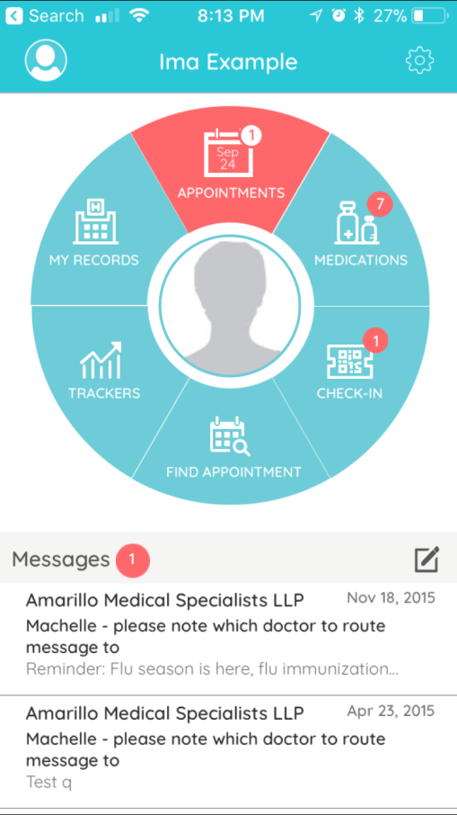

- You should see the todays visit. Tap on the icon of a TV camera where it says Televisit. You will then see ‘Appointment Details’ at the top. At the BOTTOM , there is an orange band where you can tap “Start Televisit”. Tap there when you are all ready to start.

- You will be asked for your vital signs, height, and weight. It helps us if you have those, so enter them now. If you don’t have any of these, that’s OK ! Simply leave that section blank , and then choose Start Visit.

  - It will ask for Height in feet and inches
  - Weight in pounds
  - Blood pressure Systolic (upper) then / Diastolic (lower)
  - Temperature (helps if you are complaining of any infection type symptoms.
  - Respiratory Rate – count how many breaths you take in 1 minute
  - Pulse Rate – Count the pulse at your wrist, or over your chest, for 30 seconds then multiply by 2.
  - When all is done, press Done and you will see a brief acknowledgement that the vitals are complete. You will then be taken to a screen with a doctor and computer screen on it, and the orange band Start Televisit. Press on the orange band when you are ready to see the doctor.

- You will then see “Waiting for Dr. Smith. Stand by while the doctor gets back to the desk to talk to you.”

YOUR TELEHEALTH VISIT

- When the session starts, you will be asked if Healow can access your camera and microphone. Please click OK to both of these questions.

- You will see 4 buttons at the bottom of your screen.

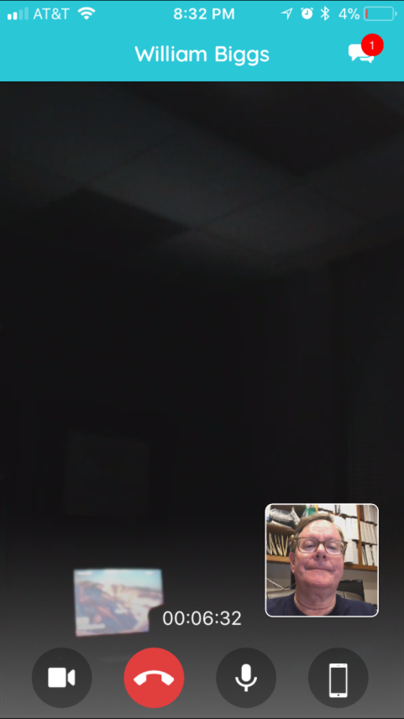

  - The Camera button turns your camera ON / OFF
  - The Red Handset button hangs up and stops your session. DON’T PRESS THIS UNTIL YOU ARE DONE !
  - The Microphone button turns your mike on or mutes it.
  - The phone button toggles your camera between the front camera to the back camera. This could be useful when showing us a rash somewhere.

- On the upper right corner is a CHAT button. If you have trouble with your sound or picture, send us a Chat text message. When we reply , you will see a little red bubble with a number there. Tap the upper right corner again to return to the video screen.
- Here is what the Chat screen looks like if you use it. Type in your message if necessary, and then send it by tapping on the triangle to the right of the message area.

To return back to the video chat, tap the little camera icon in the upper right.

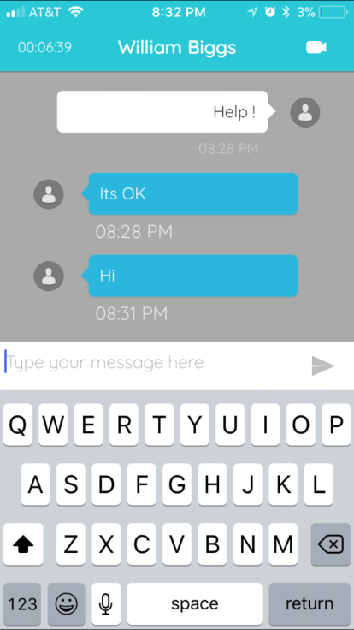

- When we are ALL DONE, that is the time to tap on the red Handset button to disconnect.

Thanks for being one of the first to use TeleHealth in Texas!

